Solace Monitoring

Nagios Setup

Use Only

July 29, 2013 Document Category: Guide

Version: 0.2

Status: Draft

Last Updated: May 07, 2014

Status: Released

Version 1.0

Developed By:  
Solace Professional Services Group

**Table of Contents**

Introduction 3

Prerequisites 3

Installation 4

Nagios 4

Nagiosgraph 6

Solace Nagios Plugin 9

NSCA 13

NagiosGrapher 17

Cacti 17

Troubleshooting 20

Additional Topics and Tasks 22

Appendix 24

Install Info 24

# Introduction

This documents intends to capture the steps required to setup monitoring Solace appliance with the open source tool Nagios.

## Prerequisites

The following tools are required to be installed and setup for complete monitoring solution.

**Platform:**

CentOS 6.3 64-bit minimal install (VMWare image)

|  |  |
| --- | --- |
| Tool | Version Tested |
| Nagios | 3.5.1 (latest is 4.0.6) |
| Nagiosgraph | 1.4.4 |
| RRDTool | 1.3.8 |

# Installation

## Nagios

### Install Prerequisites

|  |
| --- |
| # yum install -y httpd php gcc glibc glibc-common gd gd-devel make net-snmp wget  # yum install rrdtool perl-rrdtool perl-GD  # yum install perl-CGI\* perl-Time-HiRes |

### Install Nagios

|  |
| --- |
| rpm -Uvh http://dl.fedoraproject.org/pub/epel/6/x86_64/epel-release-6-8.noarch.rpm  rpm -Uvh http://rpms.famillecollet.com/enterprise/remi-release-6.rpm  yum -y install nagios nagios-plugins-all nagios-plugins-nrpe nrpe php httpd |

### Post install setup

|  |
| --- |
| # htpasswd –c /etc/nagios/passwd nagiosadmin  # service nagios start |

### Check Webadmin

Point the webbrowser to .

<http://your-server-ip/nagios>

Login with the username nagiosadmin and the password above step (htpassword command).

Sample page is shown below

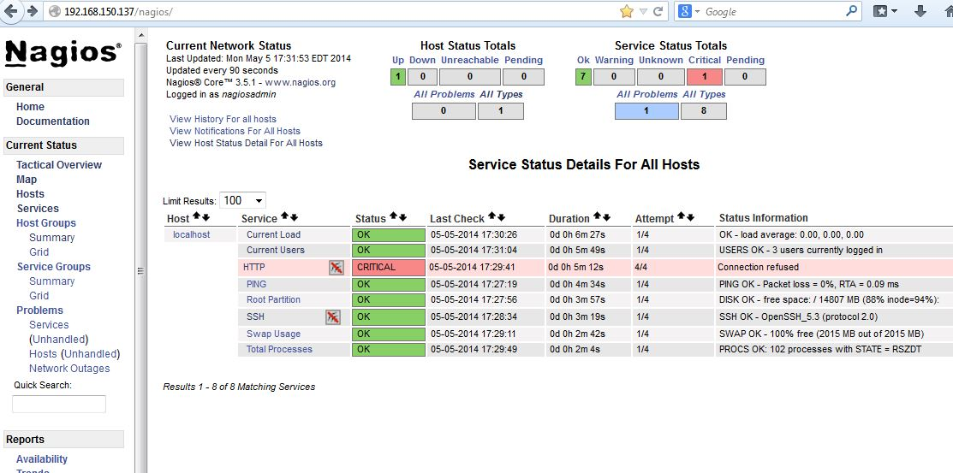

## Nagiosgraph

### Install Prerequisites

|  |
| --- |
| # yum install rrdtool perl-rrdtool perl-GD  # yum install perl-CGI\* perl-Time-HiRes |

### Install Nagiosgraph

|  |
| --- |
| # cd /opt/pkg # or path of your choice  # wget <http://downloads.sourceforge.net/project/nagiosgraph/nagiosgraph/1.4.4/nagiosgraph-1.4.4.tar.gz>  # tar -xvzf nagiosgraph-1.4.4.tar.gz  # cd nagiosgraph-1.4.4  # ./install.pl --check-prereq checking required PERL modules  Carp...1.11  CGI...3.51  Data::Dumper...2.124  File::Basename...2.77  File::Find...1.14  MIME::Base64...3.08  POSIX...1.17  RRDs...1.3008  Time::HiRes...1.9721 checking optional PERL modules  GD...2.44 checking nagios installation  found nagios at /usr/sbin/nagios checking web server installation  found apache at /usr/sbin/httpd  # ./install.pl --layout standalone --prefix /usr/local/nagiosgraph --nagios-perfdata-file=/var/log/nagios/perfdata.log --var-dir=/var/nagios/  Use defaults for all the inputs. |

### Post install setup

Run the provided setup script (setup_nagiossolace) that modifies the Config files appropriately. Edit the script and change the file paths if necessary at the top of the script.

Running setup_nagiossolace can be deferred until Solace plugins are installed (in following section).If Solace specific tools are not in place or the Config files not setup, corresponding steps will be skipped.

Warning: This is not tested on distros other than CentOS.

|  |
| --- |
| # ./setup_nagiossolace  Checking required files ...  /etc/httpd/conf/httpd.conf ok  /etc/nagios/nagios.cfg ok  /usr/local/nagiosgraph/etc/nagiosgraph/nagiosgraph.conf ok  /usr/local/nagiosgraph/etc/nagiosgraph/nagiosgraph-apache.conf ok  /etc/nagios/objects/commands.cfg ok  /usr/local/nagiosgraph/libexec/insert.pl ok  Setting up /etc/nagios/nagios.cfg ...  Setting up /etc/nagios/objects/commands.cfg ...  Setting up /usr/local/nagiosgraph/etc/nagiosgraph/nagiosgraph-apache.conf ...  Setting up /etc/httpd/conf/httpd.conf ...  Restarting services ...  Running configuration check...done.  Stopping nagios: done.  Starting nagios: done.  Stopping httpd: [ OK ]  Starting httpd: [ OK ] |

#### Restarting Services

|  |
| --- |
| # chkconfig httpd on && chkconfig nagios on  # service httpd restart  # service nagios restart |

### Check webadmin

The above script adds another host by name “localhost-gr” with graphics enabled that can be used to test the Nagiosgraph install. Sample page is shown below.

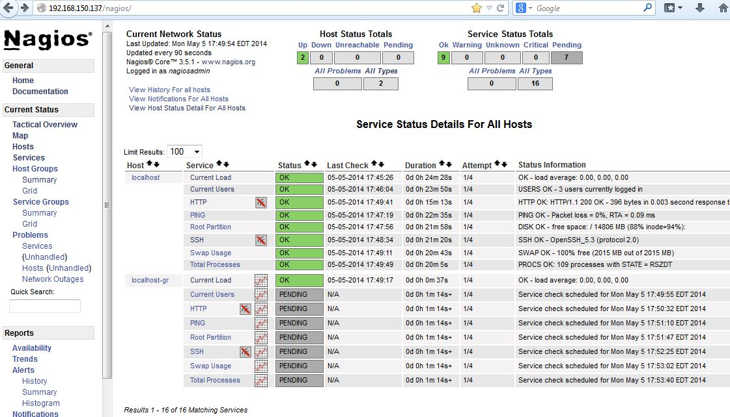

Clicking on the graph symbols to the right of service name brings up a graph with various time bracket. A sample graph for one of the services (HTTP) for a day is shown below:

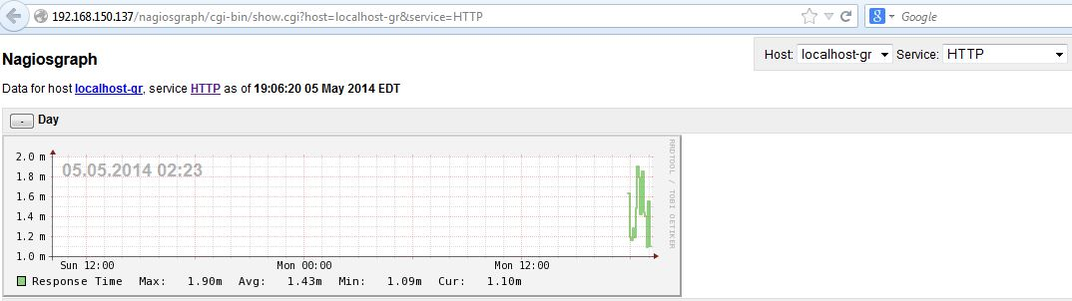

## Solace Nagios Plugin

### Install Prerequistes

|  |
| --- |
| # perl -MCPAN -e shell  ##  cpan> install Nagios::Plugin  cpan> install Nagios::Plugin::DieNicely  cpan> install LWP::UserAgent  cpan> install Nagios::Config  cpan> exit  # yum install perl-XML-LibXML |

### Create Sample file

Create a sample router Config. This file used by the setup script (below) to create commands for this config. This step can also be repeated for other routers/vpns using the command mk_nagiossolacecfg script.

|  |
| --- |
| # cat cfg/samplerouter.cfg  HOSTNAME=<solace-appliance-name>  HOSTIP=<sholace-appliance-ip>  HOSTPORT=<admin-port>  USERNAME=<username>  PASSWORD=<password>  VPNNAME=<vpn-name>  VPN_BRIDGENAME=<vpn-bridge-name> |

### Setup Plugin

Run the setup_nagiossolace script. This will setup both Nagiosgraph and the solace plugin. If Nagisgraph is already setup, the related steps will be skipped.

|  |
| --- |
| **# ./setup_nagiossolace**  Checking required files ...  /etc/httpd/conf/httpd.conf :  already setup. will be skipped  /etc/nagios/nagios.cfg :  already setup. will be skipped  /usr/local/nagiosgraph/etc/nagiosgraph/nagiosgraph.conf :  /usr/local/nagiosgraph/etc/nagiosgraph/nagiosgraph-apache.conf :  already setup. will be skipped  /etc/nagios/objects/commands.cfg :  already setup. will be skipped  /etc/nagios/objects/templates.cfg :  already setup. will be skipped  /etc/nagios/objects/localhost.cfg :  already setup. will be skipped  /usr/local/nagiosgraph/libexec/insert.pl :  Setting up config files ...  /etc/nagios/nagios.cfg:  /etc/nagios/objects/templates.cfg :  /etc/nagios/objects/localhost-graph.cfg :  /etc/nagios/objects/commands.cfg :  /usr/local/nagiosgraph/etc/nagiosgraph/nagiosgraph-apache.conf :  /etc/httpd/conf/httpd.conf :  Setting Solace for Nagios  /usr/local/nagios/plugin :  /etc/nagios/solace :  Generating Nagios config for Solace appliance ...  Using cfgfile cfg/samplerouter.cfg  Using template cfg/solace-templaterouter.cfg  Generating /etc/nagios/objects/solace-samplerouter.cfg  Restarting services ...  nagios :  nagios (pid 4542) is running...  httpd :  httpd (pid 4568) is running... |

### Post Install Setup

### Check Webadmin

If the sample router info is successfully configured, a host entry matching the appliance hostname from Config file will be added to the web page.

A sample entry is shown below:

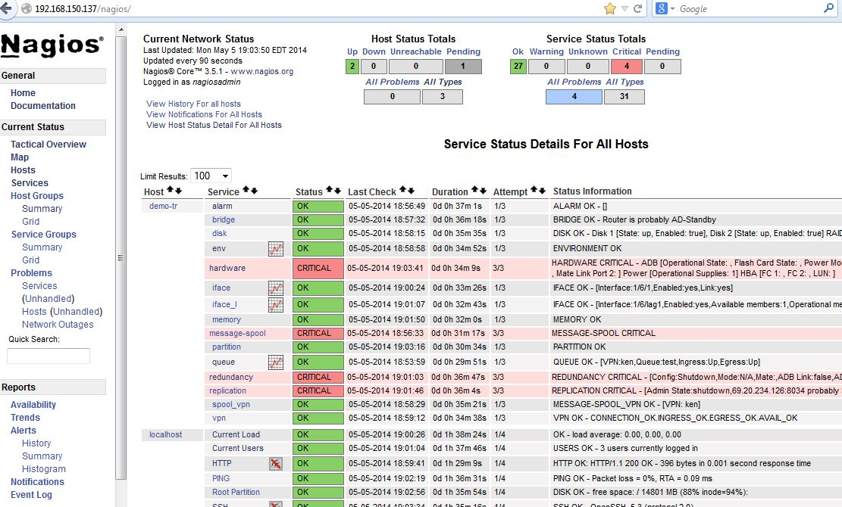

As before, clicking on the graph icon to the right of the service name brings up the graphs with options. A sample graph is shown below.

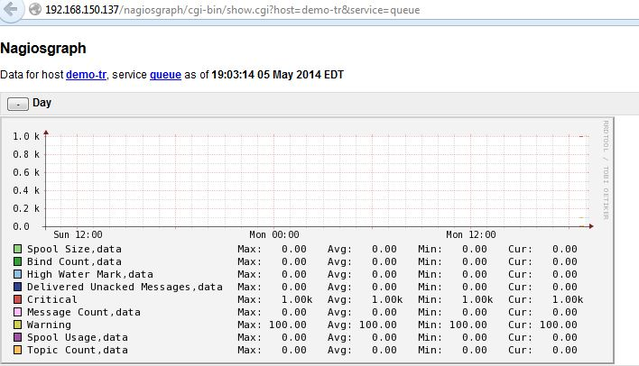

## NSCA

NSCA (Nagios Service check Acceptor) is a daemon that can accept the requests on behalf of Nagios and update the external command file. Nagios would periodically check the external command file and process them. This “**passive check**” is a way to push the external status and alerts into Nagios instead of Nagios pulling the status for configured hosts and services “actively”. The passive check offers more fine grained intervals and useful for near real time status updates and alerting.

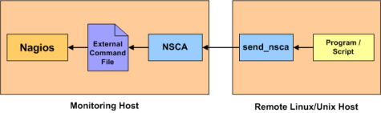

### Prerequisites

### Install NSCA

1. Download [NSCA plugin](http://exchange.nagios.org/directory/Addons/Passive-Checks/NSCA--2D-Nagios-Service-Check-Acceptor/details) from the Nagios Exchange.
2. Untar and follow install instructions in the package.

In brief

|  |
| --- |
| $ cd /opt/nsca-2.9.1/  $ ./configure  $ make all |

### Post install setup

Run ./setup_nsca script with source and target directories. The default target dir is /usr/local/nsca

This will generate required Config file and setup nsca as service.

**Check Config file /usr/local/nsca/cfg/nsca.cfg and make changes if required.**

|  |
| --- |
| # ./setup_nsca -s /opt/nsca-2.9.1/  srcdir /opt/nsca-2.9.1/ ok  target dir /usr/local/nsca ok  Checking ...  file src/nsca ok  file src/send_nsca ok  file scripts/nsca.init ok  file cfg/nsca.cfg ok  Installing ...  /usr/local/nsca/sbin/nsca :  /usr/local/nsca/bin/send_nsca :  /usr/local/nsca/cfg/nsca.cfg :  /etc/init.d/nsca :  Creating service ...  Installation complete! |

### Start service

Now that the component is installed, start it up.

|  |
| --- |
| # service nsca start  Starting nsca:  10138 |

### Test setup

Use send_alert or send_ngalert.pl wrapper to send an alert to remote host and test. Use send_alert –h / send_ngalert.pl –h for usage info.

#### Sending Host Alert

|  |
| --- |
| [root@centos-vm scripts]# ./send_ngalert.pl -n demo-tr -c OK -i Status=UP -m "remote host up"  Reading server config : /usr/local/nsca/cfg/nsca_server.cfg  starting send_nsca client ...  sending host command: demo-tr:0:remote host up - [Status=UP]  1 data packet(s) sent to host successfully. |

#### Sending Service Alert

|  |
| --- |
| # ./send_ngalert.pl -n demo-tr -s remote_alert -c CRIT -i Status=Critical -p '"Warnings"=10;10;10 "Errors"=3;10;10' -m "remote servie alert"  Reading server config : /usr/local/nsca/cfg/nsca_server.cfg  starting send_nsca client ...  sending service command: demo-tr:remote_alert:2:remote service alert - [Status=Critical] | "Warnings"=10;10;10 "Errors"=3;10;10  1 data packet(s) sent to host successfully. |

### Check WebAdmin

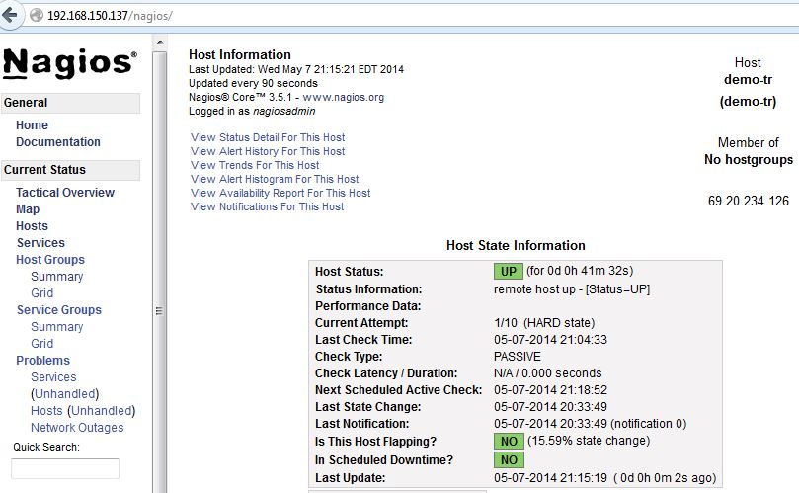

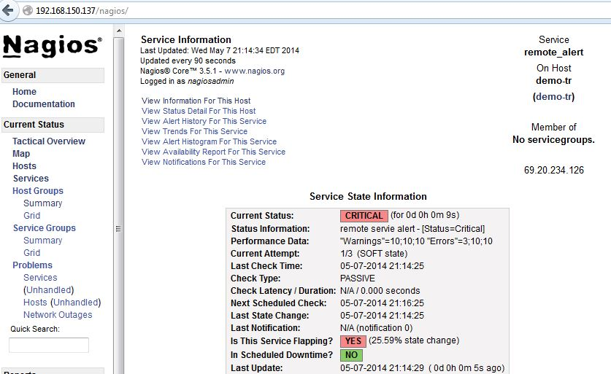

## NagiosGrapher

TODO

## Cacti

Cacti along with NagiosGrapher (above) is an alternative for NagriosGraph based monitoring discussed earlier.

TODO

### **Install Prerequisites**

#### Cacti Deppendencies

• Apache : A Web server to display network graphs created by PHP and RRDTool.  
• MySQL : A Database server to store cacti information.  
• PHP : A script module to create graphs using RRDTool.  
• PHP-SNMP : A PHP extension for SNMP to access data.  
• NET-SNMP : A SNMP (Simple Network Management Protocol) is used to manage network.  
• RRDTool : A database tool to manage and retrieve time series data like CPU load, Network Bandwidth etc.  
• UnZip : A simple tool for extracting zip files

|  |
| --- |
| Installing Apache # yum install httpd httpd-devel  Install MySQL # yum install mysql mysql-server  Install PHP # yum install php-mysql php-pear php-common php-gd php-devel php php-mbstring php-cli php-mysql  Install PHP-SNMP # yum install php-snmp  Install NET-SNMP # yum install net-snmp-utils p net-snmp-libs php-pear-Net-SMTP  Install RRDTool # yum install rrdtool  Install UnZip # yum install unzip  Add the Extra Packages for Enterprise Linux (EPEL) repository (64-Bit CentOS 6 only). This is where the Cacti installation is downloaded from. # wget http://dl.fedoraproject.org/pub/epel/5/x86_64/epel-release-5-4.noarch.rpm # wget http://rpms.famillecollet.com/enterprise/remi-release-5.rpm  # sudo rpm -Uvh remi-release-5*.rpm epel-release-5*.rpm |

### Start services

Now that all the required packages are installed, we must start their services running.

|  |
| --- |
| Start Apache # service httpd start (or restart)  Start MySQL # service mysqld start  Start SNMP # service snmpd start  Setup start up links for Apache, MySQL and SNMP Apache # /sbin/chkconfig --levels 345 httpd on  MySQL # /sbin/chkconfig --levels 345 mysqld on  SNMP # /sbin/chkconfig --levels 345 snmpd on |

### Install Cacti

|  |
| --- |
| Download and Install Cacti # yum install cacti |

### Post Install

### MySQL Setup

|  |
| --- |
| Setup MySQL Server for Cacti # mysqladmin -u root password Desired-Password-Here   Create MySQL Cacti Database # mysql -u root -p mysql> create database cacti; mysql> GRANT ALL ON cacti.* TO cacti@localhost IDENTIFIED BY ‘Password-you-set-above’; mysql> FLUSH privileges; mysql> quit;  Now we need to install the tables into the cacti.sql file. Use the following command to do this, replace the green text for the location shown by the command above.  # mysql -u cacti -p cacti < `# rpm -ql cacti | grep cacti.sql` |

** NOT COMPLETE **

# Troubleshooting

### Nagios not starting up

Check Config file for any errors. (sample error below)

|  |
| --- |
| **# /usr/sbin/nagios -v /etc/nagios/nagios.cfg**  Nagios Core 3.5.1  Copyright (c) 2009-2011 Nagios Core Development Team and Community Contributors  Copyright (c) 1999-2009 Ethan Galstad  Last Modified: 08-30-2013  License: GPL  Website: http://www.nagios.org  Reading configuration data...  Read main config file okay...  Processing object config file '/etc/nagios/objects/commands.cfg'...  Warning: Duplicate definition found for command 'process-service-perfdata' (config file '/etc/nagios/objects/commands.cfg', starting on line 243)  Error: Could not add object property in file '/etc/nagios/objects/commands.cfg' on line 244.  Error processing object config files!  ***> One or more problems was encountered while processing the config files...  Check your configuration file(s) to ensure that they contain valid  directives and data defintions. If you are upgrading from a previous  version of Nagios, you should be aware that some variables/definitions  may have been removed or modified in this version. Make sure to read  the HTML documentation regarding the config files, as well as the  'Whats New' section to find out what has changed. |

### Can't access http from outside

telnet server 80 fails as well.

Check Iptables routes:

|  |
| --- |
| # iptables -I INPUT 5 -i eth0 -p tcp --dport 80 -m state --state NEW,ESTABLISHED -j ACCEPT  # iptables -I INPUT 5 -i eth0 -p tcp --dport 443 -m state --state NEW,ESTABLISHED -j ACCEPT  # iptables-save | tee /etc/sysconfig/iptables  # service iptables save  # service iptables restart |

### CGI Error in show.cgi

Check http error.log

[Fri May 02 02:21:12 2014] [error] [client 192.168.150.1] (13)Permission denied: exec of '/usr/local/nagios/sbin/show.cgi' failed, referer: http://192.168.150.137/nagios/cgi-bin//status.cgi?host=all  
[Fri May 02 02:21:12 2014] [error] [client 192.168.150.1] Premature end of script headers: show.cgi, referer: [http://192.168.150.137/nagios/cgi-bin//status.cgi?host=all](http://192.168.150.137/nagios/cgi-bin/status.cgi?host=all)

1. Check file and dir permissions. They should be world readable and executable.
2. Check SE (Security Enhanced Linux) Mode

|  |
| --- |
| # chmod go+rx /usr/local/nagios/sbin/  # chmod go+rx /usr/local/nagios/sbin/show.cgi  # **setenforce 0**  # service httpd restart # service nagios restart |

### CGI Error in Solace graphs

Check that the CGI scripts are runnable from command line.

Check for missing required modules and Perl libraries.

|  |
| --- |
| # /usr/local/nagios/plugins/disk.pl -r solace-router:port -u user -p password -v  DISK OK - Disk 1 [State: up, Enabled: true], Disk 2 [State: up, Enabled: true] RAID [in fully redundant state] |

### Can’t stat command file error

If you see error

Error: Could not stat() command file ‘/usr/local/nagios/var/rw/nagios.cmd’!

|  |
| --- |
| # chcon -R -t httpd_sys_script_rw_t /usr/local/nagios/var/rw  (change path based on the error message) |

# Additional Topics and Tasks

### Creating custom Maps

Create custom maps for any outputs that need it, for example turn the iface counter values into gauge:

Add to /usr/local/nagiosgraph/etc/nagiosgraph/map

|  |
| --- |
| #######################  # Service type: iface  # output:IFACE OK - [Interface:1/6/1,Enabled:yes,Link:yes]  # perfdate: rx-pkts=365832598;; rx-bytes=108312525627;; tx-pkts=390410814;; tx-bytes=363571175913;;  /perfdata:rx-pkts=(\d+);; rx-bytes=(\d+);; tx-pkts=(\d+);; tx-bytes=(\d+);;/  and push @s, [ 'if_stats',  ['tx-pkts', COUNTER, int $1 ],  ['rx-pkts', COUNTER, int $2 ],  ['tx-bytes', COUNTER, int $3 ],  ['rx-bytes', COUNTER, int $4 ] ]; |

### Adding additional routers / VPNs

Use cfg/samplerouter.cfg as template to create additional router, VPN or VPN bridge configuration. Run mk_nagiossolacecfg to generate required solace plugin Config files.

Alternatively the files can be edited or added in /etc/nagios/objects dir manually. The corresponding entries need to be added into /etc/nagios/nagios.cfg file.

Note that the services need to be restarted for the changes to be effective.

|  |
| --- |
| **# ./mk_nagiossolacecfg cfg/demo-tr.nram_test1**  Generating Nagios config for Solace appliance ...  Using cfgfile cfg/demo-tr.nram_test1  Using template cfg/solace-templaterouter.cfg  Generating config ...  /etc/nagios/objects/solace-demo-tr.cfg :  Setting up config files ...  /etc/nagios/nagios.cfg :  **# service httpd restart && service nagios restart**  Stopping httpd: [ OK ]  Starting httpd: [ OK ]  Running configuration check...done.  Stopping nagios: done.  Starting nagios: done. |

### Remote syslog processing

TODO

Set up to receive remote syslog messages

|  |
| --- |
| # Provides UDP syslog reception  $ModLoad imudp  $UDPServerRun 514  # Provides TCP syslog reception  $ModLoad imtcp  $InputTCPServerRun 514  # This one is the template to generate the log filename dynamically, depending on the client's IP address.  $template FILENAME,"/var/log/%fromhost-ip%/syslog.log"  # Log all messages to the dynamically formed file. Now each clients log will be under a separate directory which is formed by the template FILENAME.  *.* ?FILENAME |

### Changing update frequency

TODO

### Active vs Passive Monitoring

TODO

# Appendix

## Install Info

Default install paths

|  |  |
| --- | --- |
| HTTP (Apache) | |
| Config | /etc/httpd/conf/httpd.conf |
| Logs | /var/log/httpd/error_log, /var/log/httpd/access_log |
|  |  |
| Nagios | |
| Config file | /etc/nagios/nagios.cfg |
| Commands | /etc/nagios/objects/commands.cfg |
| Log | /var/log/nagios/nagios.log |
| Perfdata log | /var/log/nagios/perfdata.log |
| Config Dir | /etc/nagios/objects |
| Command file | /var/spool/nagios/cmd/nagios.cmd |
|  |  |
| RRD | |
| Data dir | /var/nagios/rrd |
|  |  |
| Nagiosgraph | |
| Config | /usr/local/nagiosgraph/etc /nagiosgraph.conf |
| Apache config | /usr/local/nagiosgraph/etc /nagiosgraph-apache.conf |
| Log | /usr/local/nagiosgraph/var/nagiosgraph.log |
|  |  |
| Nagios Solace | |
| Config | /etc/nagios/solace/solace.cfg |
| Plugin dir | /usr/local/nagios/plugins |
|  |  |
| NSCA Daemon and Agent | |
| Path | /usr/local/nsca/ |
| Config (server) | /usr/local/nsca/cfg/nsca.cfg |
| Config (client) | /usr/local/nsca/cfg/nsca_server.cfg  /usr/local/nsca/cfg/nsca_client.cfg |